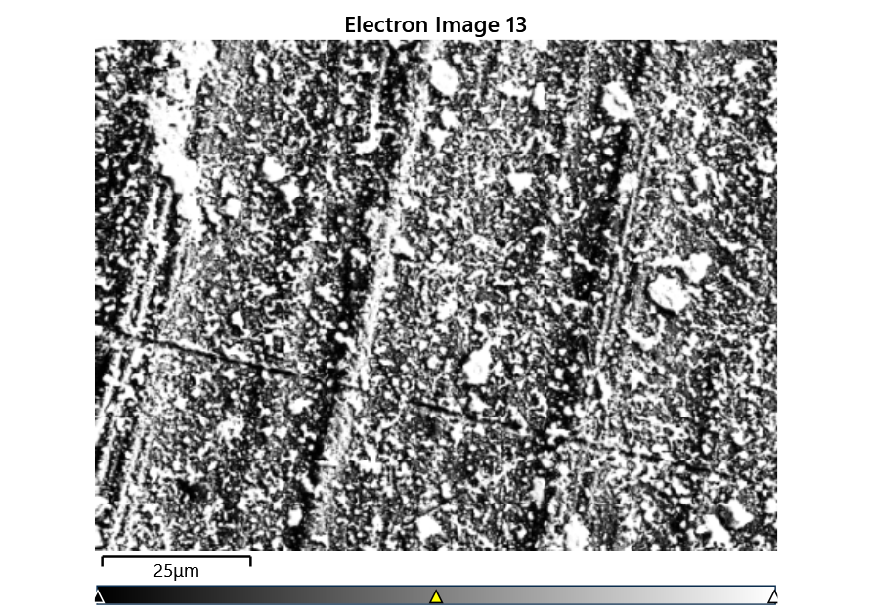



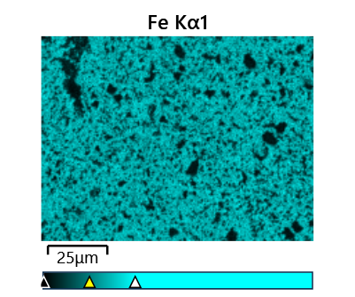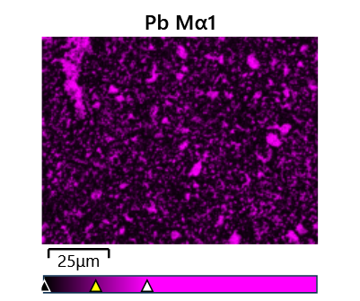

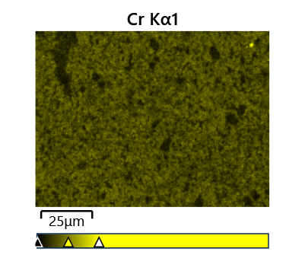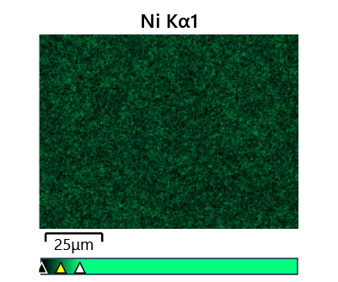

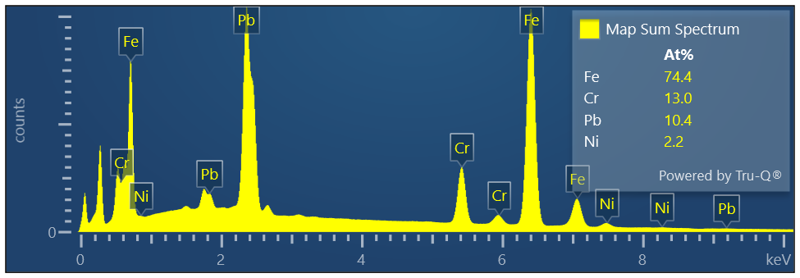

Map Sum Spectrum

Element Signal Weight % σ

Fe 58.43 0.05

Pb 30.24 0.05

Cr 9.47 0.02

Ni 1.85 0.03

**Map Sum Spectrum**

**Element Signal Atomic % σ**

**Fe 74.42**

**Cr 12.96**

**Pb 10.38**

**Ni 2.24**